# CS 255 System Design Document Template

## UML Diagrams

### UML Use Case Diagram

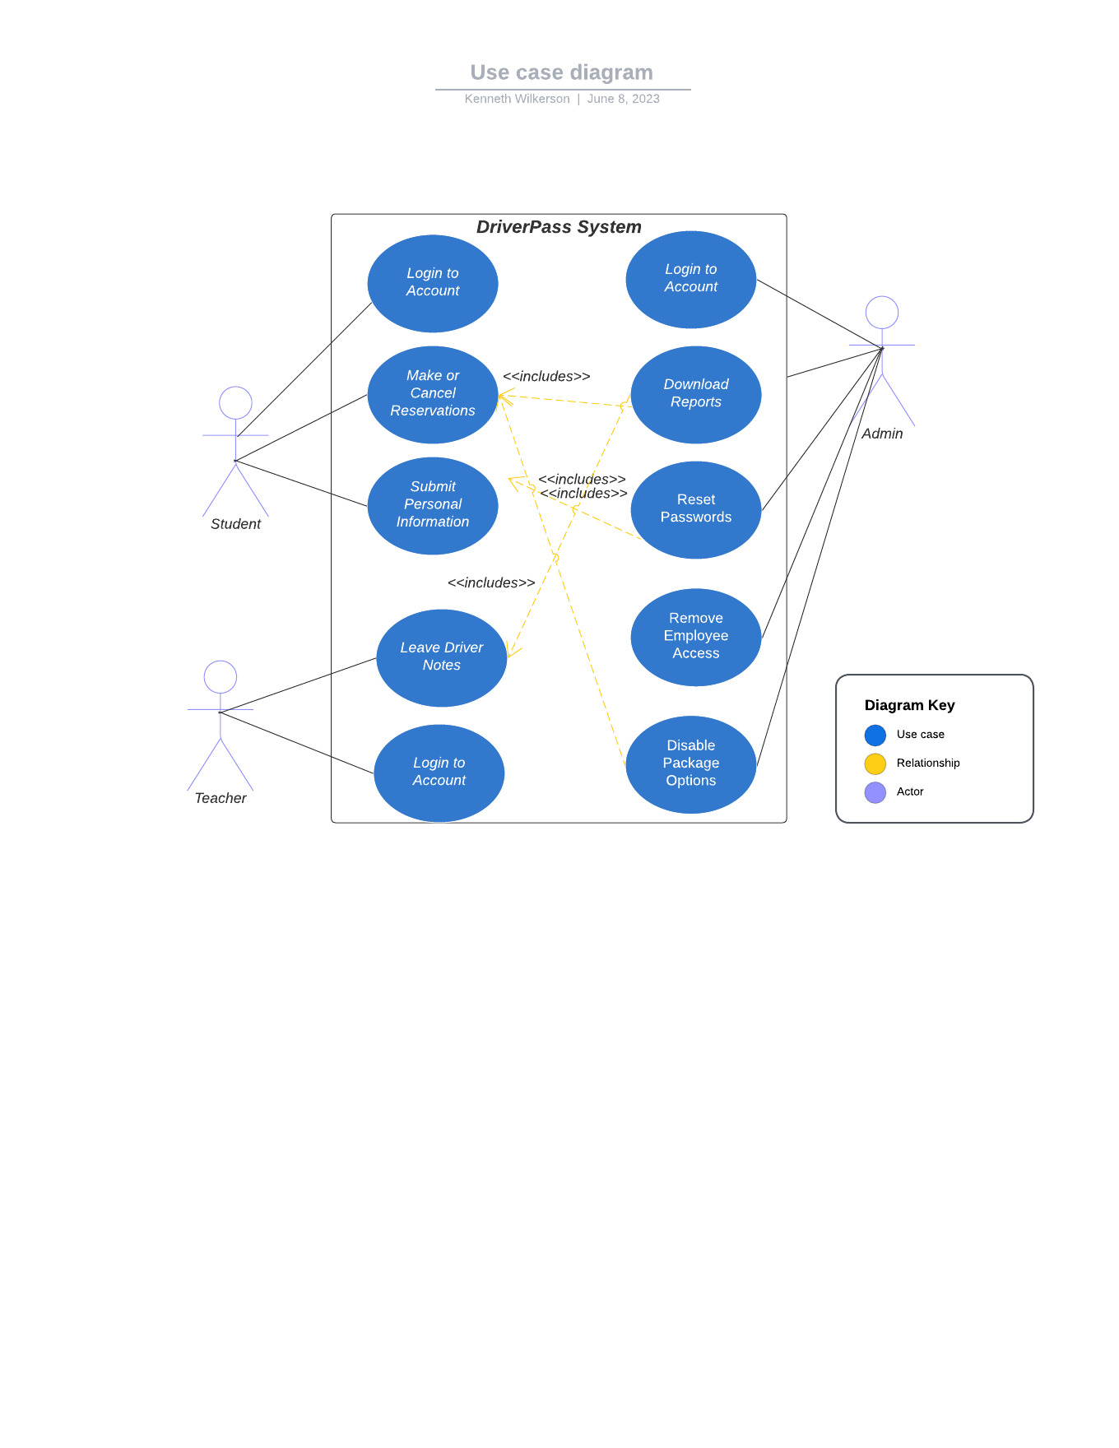

### UML Activity Diagrams

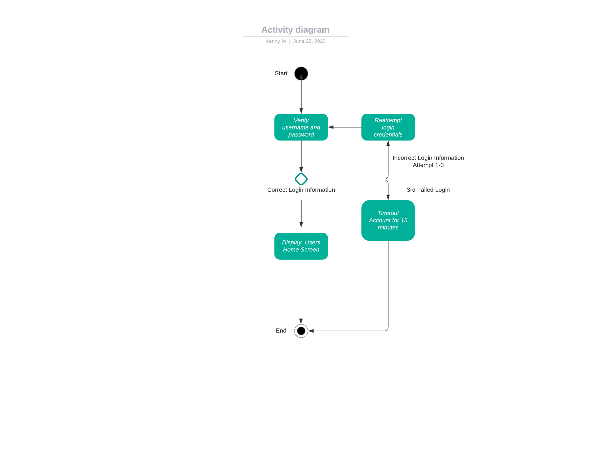

### Activity diagram2.jpeg

### UML Sequence Diagram

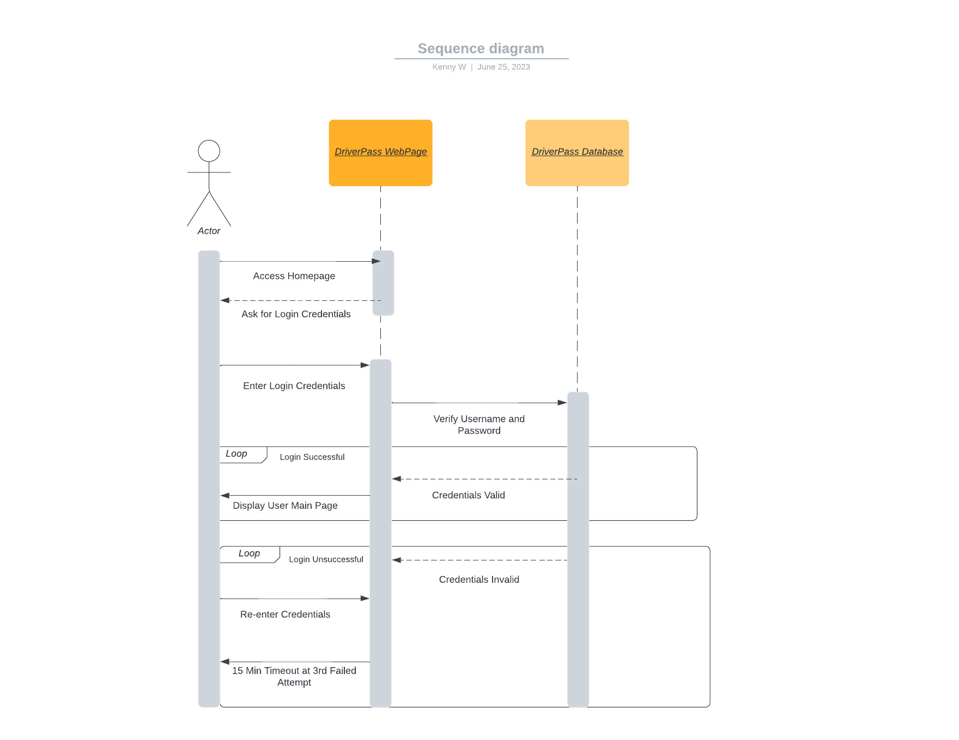

### UML Class Diagram

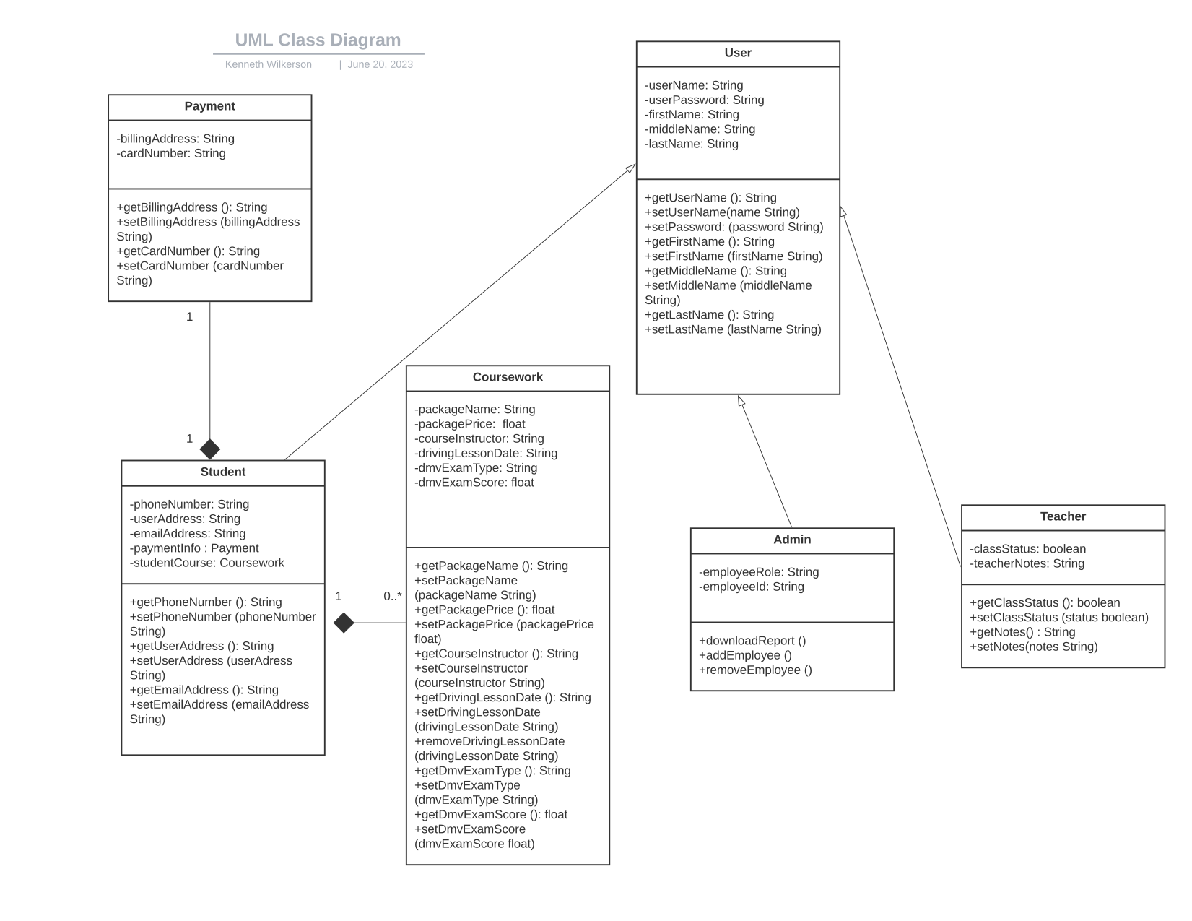

## Technical Requirements

***Hardware:***

*The DriverPass system is compatible with all of the following types of hardware*

* *Desktop computers*
* *Laptops*
* *All smartphones with web browsers*
* *Other capable devices such as tablets*

***Software:***

*Since DriverPass is a web based application, it run on all operating systems such as*

* Windows
* MacOS
* Linux

*Compatible with all web browsers such as*

* *Microsoft Edge*
* *Google Chrome*
* *Safari*
* *Firefox*

***Tools:***

The following tools will be useful in the development of the DriverPass system

* *Eclipse IDE*
* *Github*
* *Microsoft Project*
* *Microsoft Teams or Zoom*
* *Lucidchart (UML Diagrams)*

***Infrastructure:***

* *High speed internet connection and a web server such as Microsoft IIS*
* *Microsoft Azure cloud services, pay according to storage capacity needs*
* *MicrosoftSQL database server for data storage and retrieval*